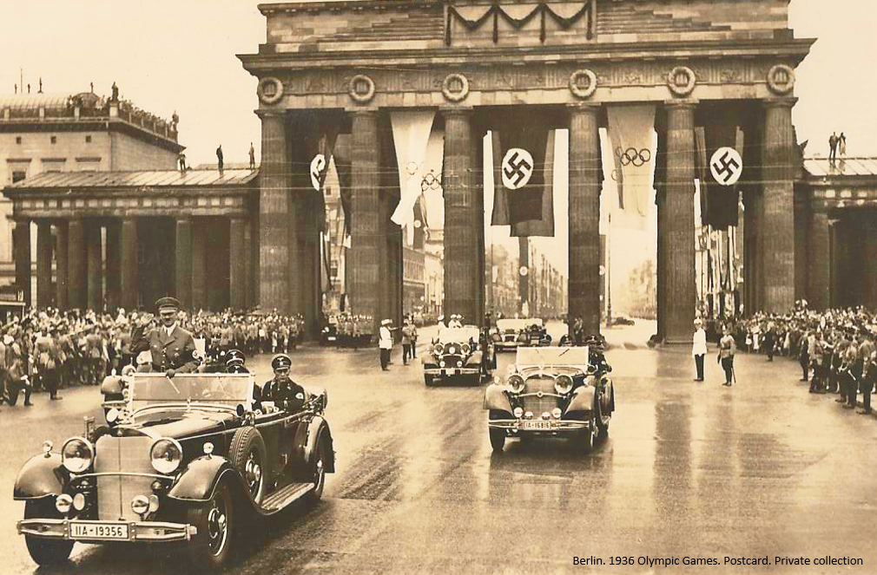
Olympic Movement and Wars
Olympism, Propaganda, Boycotts and Terrorism
National Olympic Committee of Portugal, 5th and 6th July 2016
The Olympic Charter states in its Chapter 5 that “[n]o kind of demonstration or political, religious or racial propaganda is permitted in any Olympic sites, venues or other areas”. Yet the modern Olympic movement has been threatened by wars, boycotts, protests and terrorist attacks, which damage the belief that the competition should represent the noblest sports practice. The purpose of Pierre de Coubertin when he founded the modern Olympic movement was to recover the power and the international respect that France had lost as a result of the defeat in the 1870 Franco-Prussian war. Coubertin declared then that the solution for the French problems was to be found in the scope of an active promotion of physical strength and of sports activities due to be understood as a positive and influential tool within the cultural and political performances. Physical strength and sports activities should also be acknowledged as important enhancers of friendship, solidarity and fair play among athletes, governments’ delegates and journalists at a transnational level. That was the time when all sports victories achieved by a state were immediately understood as the result of a political superiority of its regime; and in 1936 in Portugal the newspapers praised the perfect German organization and the magnificence of the event.
One hundred years ago, for the first time since their relaunching, the Olympic Games did not take place due to a massive military conflict, the First World War; one hundred years ago Portugal joined that same conflict; and 80 years ago Adolf Hitler used the Berlin 1936 Olympics, the XI Summer Games, for propagandistic purposes, promoting the image of a tolerant and at peace Germany, masking the racist and anti-Semitic core of the Nazi dictatorship.
The conference Olympic Movement and Wars seeks to examine the political dimension of sport and the impacts of world wars, diplomatic conflicts, terrorism and the relations among states within the scope of the Olympic movement and along the evolution of the athletes’ careers in the past one hundred years.
With the purpose of inviting new perspectives for analysing the history of the Olympism from an interdisciplinary standpoint, this conference welcomes contributions which address, but are not limited to, the following thematic subjects:
- The political dimension of the Olympic Games within war contexts;
- The Olympic Games as a tool used by international politics;
- The recruitment of the athletes for war and its impact in the development of certain modalities;
- The banning of Jewish and Gipsy athletes from the German sports organizations in the 30’s of the 20th century and the Second World War;
- The 1936 Olympic Games and the use of sport to promote political ideologies;
- The Cold War and the Olympic victories as a vehicle for communist propaganda;
- The invasion of Afghanistan and the boycotts to the participation in the Olympic Games;
- The Olympic movement after the wars: from the Inter-Allied Games (1919) to the end of the Cold War (1989);
- Olympism and terrorism; the risks of Olympic tourism.

This conference will include presentations delivered by invited speakers, as well as papers submitted via this call for papers.
Proposals will be selected with the purpose of ensuring the high level of quality and diversity of the presented studies.

Deadline for submissions: 15th January 2016 to 31st March 2016
Send: title of your presentation, abstract (700 words), affiliation and academic CV (1 page)
Please, send your identification (name, institutional affiliation and email) and your abstract via email to warolimpics@gmail.com.
Conference languages: Portuguese and English (there will be no simultaneous translation)
Organizing Committee:
Ana Paula Pires (IHC-FCSH-UNL)
António Paulo Duarte (IDN & IHC-FCSH-UNL)
Cândida Cadavez (Escola Superior de Hotelaria e Turismo & IHC-FCSH-UNL)
Rita Nunes (Comité Olímpico de Portugal & IHC-FCSH-UNL)

Venue:
Comité Olímpico de Portugal
Travessa da Memória, 36, 1300-403 Lisboa
GPS: 38°42'10.4"N 9°12'02.7"W
Fee: More Information:
10€ – Students https://warolympics.wordpress.com/
20€ - Other researchers, Public in general warolimpics@gmail.com

